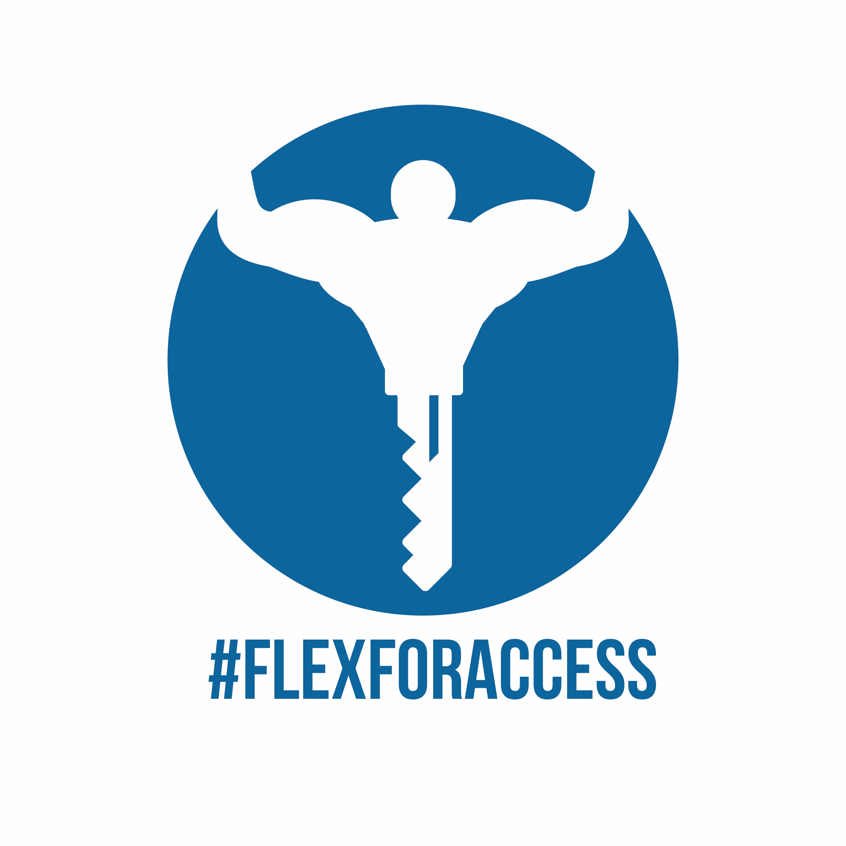

www.flexforaccess.ca

Flex for Access Inc. Application for Funding Form

Flex for Access Inc. is an organization dedicated to raising awareness of adaptive fitness and sport for all, and to raise funds to facilitate adaptive training sessions and classes in participating gyms and studios as well as for adaptive exercise equipment

Client criteria

-Must be between the ages of 9-44 in some cases Flex for Access works with clinics that have older clients in need of session facilitation if there is a previous history and clearance for sessions.

-Must be limited in mobility due to injury of physical challenge such as (Cerebral Palsy, MS, an ABI or SCI)

-Client must face barrier to facilitating (paying for) gym training sessions or fitness-oriented rehab in order to have it facilitated by Flex for Access.

-Client must be able to schedule their own sessions and commit to an arrangement with the trainer and/ or therapist or practitioner.

Social Media and Testimonial/ progress post Consent

Flex for Access’ work is centred on creating and leveraging awareness of adaptive fitness and sport promotion for disability and injury management.

This awareness and educational component is achieved by Social Media collaboration through using the hashtag #flexforaccess in content where the client, team, or athlete is flexing their bicep in support.

The hashtag #flexforaccess is also to be used in class or training sessions posts and _________________(gym, studio clinic)_ and ________________(
client name)give consent for Flex for Access to repost and share the post on their platforms and in presentations, for the purposes or showcasing participation and involvement.
Signed or can provide gym/ clinic studio can provide e-mail consent

_____________Jess Silver, Founder of Flex for Access. __________

Name____________________________

Condition __________________________

Age________________

- Why do you want to start training or continue?

________________________________________________________________________________________________________________________________________________________________________________________________________________________________________________________________________________________________________________________________________________________________________________________________________________________________________________________________________________________________________________________________________________________________________________________________________________________________________________________________________________________________________________________________________________________________________________________________________________________

- Why/ how have you found it important for your daily life, quality of life, and progress?

________________________________________________________________________________________________________________________________________________________________________________________________________________________________________________________________________________________________________________________________________________________________________________________________________________________________________________________________________________________________________________________________________________________________________________________________________________________________________________________________________________________________________________________________________________

- How long have you been training for? Or if you didn’t train what was your regiment like before?

________________________________________________________________________________________________________________________________________________________________________________________________________________________________________________________________________________________________________________________________________________________________________________________________________________________________________________________________________________________________________________________________________________________________________________________________________________________________________________________________________________________________________________________________________________________________________________________________________________________________________________________________________________________________________________________________________________________________________________________________________________________________________________________________________________________________________________________________________________________________________________________________________________________________________________________________________

- What would you like to learn or improve upon?
______________________________________________________________________________________________________________________________________________________________________________________________________________________________________________________________________________________________________________________________________________________________________________________________________________________________________________________________________________________________________________________________________________________________________________________________________________________________________________________________________________________________________________________________________________________________________________________________________________________________________________________________________________________________________________________________________________________________________________________________________________________________________________________

- How do you hope Flex for Access Inc. will help motivate you and keep you on track with achieving your fitness/ rehab goals? Do you think an organization like Flex for Access Inc. is important for education and social awareness purposes of fitness and disability management?

________________________________________________________________________________________________________________________________________________________________________________________________________________________________________________________________________________________________________________________________________________________________________________________________________________________________________________________________________________________________________________________________________________________________________________________________________________________________________________________________________________________________________________________________________________________________________________________________________________________________________________________________________________________________________________________________________________________________________________________________________________________________________________________________________________________________________________________________________________________________________________________________________________________________________________________________________________________________________________________________________________

